**RIPHAH INTERNATIONAL UNIVERSITY, ISLAMABAD**



**Lab 3**

**Bachelors of Computer science – 5th semester**

**Subject:** Artificial Intelligence Lab

**Submitted to:** Ma’am Ayesha

**Submitted by:** Munaza Malik

**Sap Id:** 44956

**Date:** 18th February, 2025

**Task 1:**

Program to check whether the number is single digit, double digit or triple digit?

**Code:**

num = int(input("Enter a number: "))  
  
if num < 10:  
 print("Single digit number")  
elif num < 100:  
 print("Double digit number")  
elif num < 1000:  
 print("Triple digit number")  
else:  
 print("More than three digits")

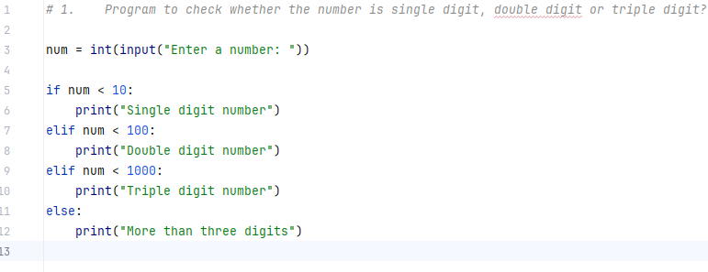

**Output:**

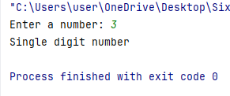

**Task 2:**

Write a program in which take a value from user and check whether the entered number is Odd or Even?

**Code:**

num = int(input("Enter a number: "))  
  
if num % 2 == 0:  
 print("Even number")  
else:  
 print("Odd number")

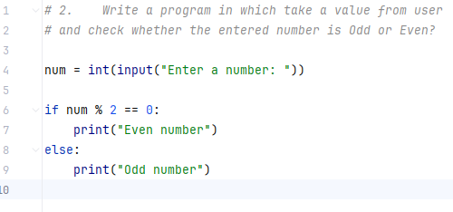

**Output:**

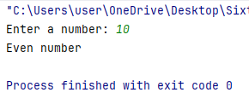

**Task 3:**

Take values of length and breadth of a rectangle from user and check if it is square or not.

**Code:**

length = float(input("Enter the length of the rectangle: "))  
breadth = float(input("Enter the breadth of the rectangle: "))  
  
if length == breadth:  
 print("It is a square")  
else:  
 print("It is not a square")

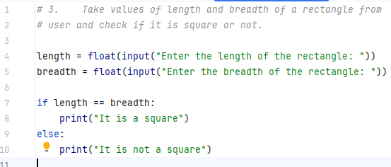

**Output:**

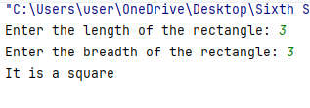

**Task 4:**

A company decided to give bonus of 5% to employee if his/her year of service is more than 5 years. Ask user for their salary and year of service and print the net bonus amount.

**Code:**

salary = float(input("Enter your salary: "))  
years_of_service = int(input("Enter years of service: "))  
  
if years_of_service > 5:  
 bonus = salary * 0.05  
 print(f"Your bonus amount is: {bonus}")  
else:  
 print("No bonus awarded")

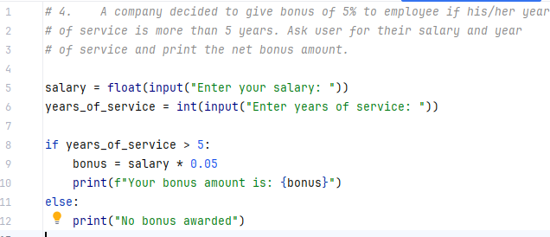

**Output:**

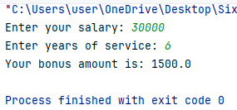

**Task 5:**

Write a program that checks if a given year is a leap year. A year is a leap year if:

It is divisible by 4, but not by 100, unless it is also divisible by 400.

**Code:**

year = int(input("Enter a year: "))  
  
if (year % 4 == 0 and year % 100 != 0) or (year % 400 == 0):  
 print("Leap year")  
else:  
 print("Not a leap year")

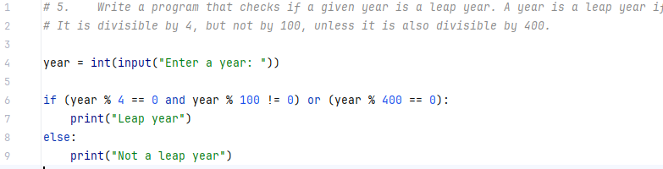

**Output:**

